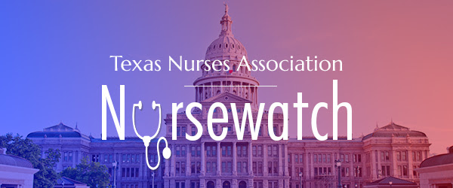

NLAC Update: NOVEMBER 2020
NLAC met virtually in October to share members' individual legislative agendas, get a legislative overview of the upcoming session, and hear from the Board of Nursing and key health stakeholders Texas Medical Association and the Texas Hospital Association. After the meeting, NLAC representatives were sent a survey to finalize the 2021 Nursing Legislative Agenda, which will be publicized on NLAC's web page soon.
The survey also revealed that 100% of respondents indicated that their organization participation in NLAC has been beneficial. One member stated"This is a great organization for Texas nurses. We stay informed regarding legislative nursing issues as well as all nursing issues.I believe we are the only state that has this group."
The 2021 Texas Legislature could be pivotal for addressing important nursing concerns from education funding to workplace advocacy and prevention of violence to numerous other issues that affect the profession. There is strength and influence in numbers. Now is the time for professional nursing organizations in Texas to come together and work with the Texas Legislature to improve and protect the nursing profession and healthcare for all Texans.
Enrollment for 2021-2022 NLAC membership opens this month. Invoices will be sent to NLAC primary representatives, and we will reach out to share the benefits of NLAC membership with professional nursing organizations in Texas that are not yet members. Now is the time to rejoin NLAC and encourage other Texas professional nursing organizations that aren't yet members to join us in amplifying the voice of nursing at the state Capitol. The upcoming legislative session is ripe with opportunity and frontline health care workers have an important perspective to share with state lawmakers.

